### Project Name: Job Application Tracking System - (Developer)

### Team ID : LTVIP2024TMID11609

### Team Leader : S MOHAN

### Salesforce

**Creating A Salesforce Developer Org**

A Developer org has all the features and licenses you need to get started with Salesforce.  
  
1.Search Developer.salesforce.com/signup  
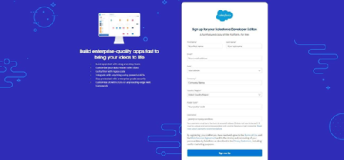   
2.Enter the following details like First name, last name, Email, Role, Company, Country/Region, Postal code, and Username must be unique.  
  
3.Click sign me up, after a few min you will reserve a mail salesforce org and by using the verify account link you can create your new password.  
  
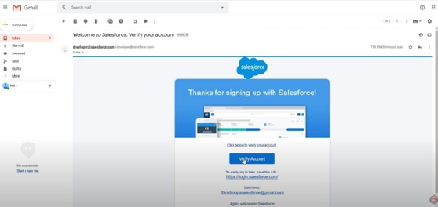  
  
4. Click save.  
  
5.Search login.salesforce.com  
  
6.By using username and password you can into the Salesforce org.  
  
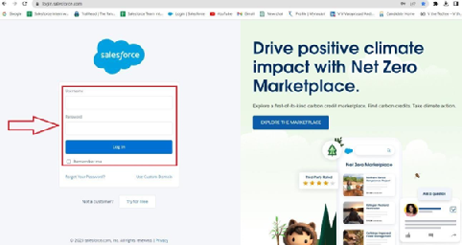  
  
The home page will appear as below.

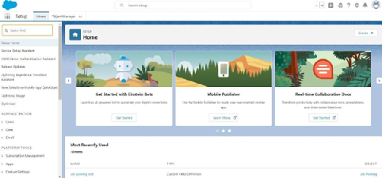

### Object

**Create A Custom Object For Recruiter**

Create a custom object for Recruiter:  
  
To create a custom object, follow these steps:  
1. From setup click on object manager.  
2. Click create, select custom object.  
  
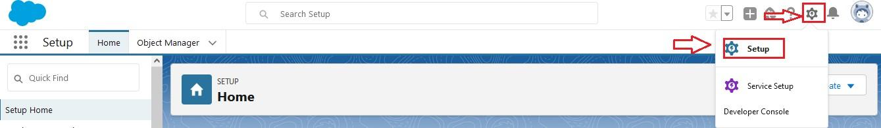  
  
  
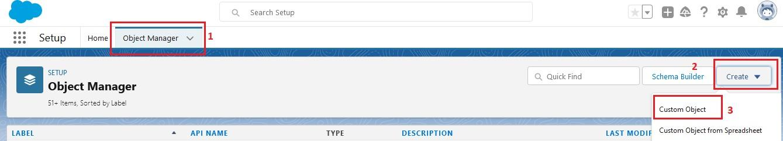  
  
  
  
  
3. Fill in the label as " Recruiter ".  
4. Fill in the plural label as " Recruiters".  
5. Record name: " Recruiter Name"  
6. Select the data type as "Text".  
7. In the Optional Features section, select Allow Reports and Track Field History.  
8. In the Deployment Status section, ensure Deployed is selected.  
9. In the Search Status section, select Allow Search.  
10. In the Object Creation Options section, select Add Notes and Attachments related list to default page layout.

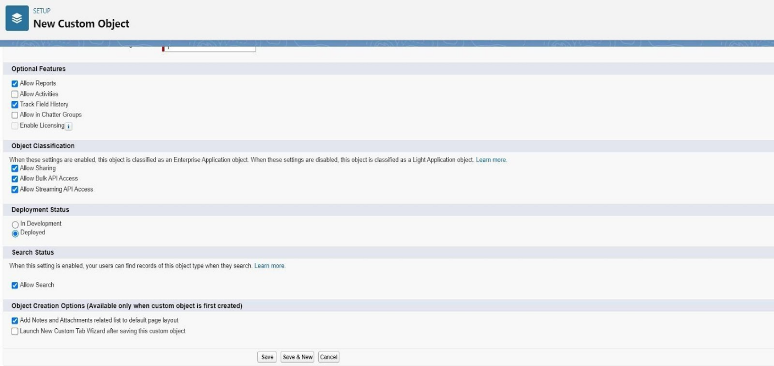

11. Leave everything else as is, and click Save.

**Creation Of Jobs Object**

Click on the gear icon and then select Setup.  
  
1. Click on the object manager tab just beside the home tab.  
  
2. After the above steps, have a look on the extreme right you will find a Create Dropdown click on that and select Custom Object.  
  
3. On the Custom Object Definition page, create the object as follows:

* Label: Job
* Plural Label: Jobs
* Record Name: Job Name
* Select the data type as "Text".
* Check the Allow Reports checkbox
* Check the Allow Search checkbox
* In the Object Creation Options section, select Add Notes and Attachments related list to default page layout
* Click Save.

**Creation Of Candidate Object**

1. Click on the gear icon and then select Setup.
2. Click on the object manager tab just beside the home tab.
3. After the above steps, have a look on the extreme right you will find a Create Dropdown click on that and select Custom Object.

* On the Custom Object Definition page, create the object as follows:
* Label: Candidate
* Plural Label: Candidates
* Record Name: Candidates Name
* Select the data type as "Text".
* Check the Allow Reports checkbox.
* Check the Allow Search checkbox.
* In the Object Creation Options section, select Add Notes and Attachments related list to default page layout.
* Click Save.

**Creation Of Job Application Object**

* Click on the gear icon and then select Setup.
* Click on the object manager tab just beside the home tab.
* After the above steps, have a look on the extreme right you will find a Create Dropdown click on that and select Custom Object.
  + On the Custom Object Definition page, create the object as follows:
  + Label: Job Application
  + Plural Label: Job Applications
  + Record Name: Job Application Number
  + Select the data type as "Auto Number".
  + Under display format enter "JP-{0000}"
  + Enter starting number as 1
  + Check the Allow Reports checkbox.
  + Check the Allow Search checkbox.
  + In the Object Creation Options section, select Add Notes and Attachments related list to default page layout.
  + Click Save.

### Tab

**Creation Of Recruiter Tab**

Now create a custom tab.

Click on Home tab, enter Tabs in Quick Find and select Tabs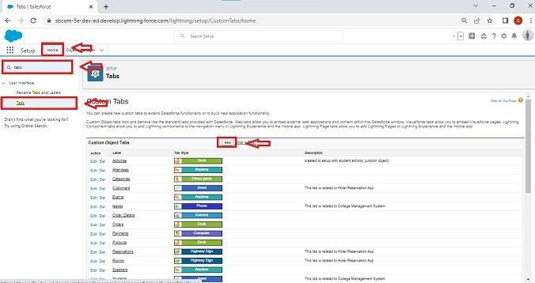  
  
  
  
2.Under custom object tabs, click New.  
  
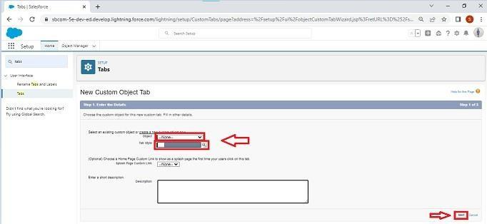  
  
3.For Object, select Recruiter.  
4.For Tab Style, select any icon.  
5.Leave all defaults as is. Click Next, Next, and Save.

**Creation Of Job Tab**

Now create a custom tab.

1. Click on Home tab, enter Tabs in Quick Find and select Tabs.  
2. Under custom object tabs, click New.  
3. For Object, select Job.  
4. For Tab Style, select any icon.  
5. Leave all defaults as is. Click Next, Next, and Save.

**Creation Of Candidate Tab**

Now create a custom tab.

1. Click on Home tab, enter Tabs in Quick Find and select Tabs.
2. Under custom object tabs, click New.
3. For Object, select Candidate.
4. For Tab Style, select any icon.
5. Leave all defaults as is. Click Next, Next, and Save.

**Creation Of Job Application Tab**

Now create a custom tab.

1. Click on Home tab, enter Tabs in Quick Find and select Tabs.
2. Under custom object tabs, click New.
3. For Object, select Job Application.
4. For Tab Style, select any icon.
5. Leave all defaults as is. Click Next, Next, and Save.